OZ HOTELS SUI RESORT
2024 SUMMER FACT SHEET

(it is valid April 1st and November 5th 2024.)
ADDRESS: Okurcalar Mah. 1001 Sok. Alanya /Antalya /Türkiye Tel: +90 (242) 510 19 00
Fax: +90 (242) 510 19 10
Web Site: www.ozhotels.com.tr E-Mail: sui@ozhotels.com.tr

LOCATION:

SUI RESORT was established on 9000m² area with its fascinating atmosphere purified from noise of the city and calm in Okurcalar area of Alanya, the pearl of the Mediterranean Sea and it consists of 303 comfortable rooms. It is located at 108 km away from Antalya city centrum, 98 km from Antalya Airport and 30 km from Alanya. It is locate 500 m away from the sea, it has its own beach and there is a shuttle service all day long.
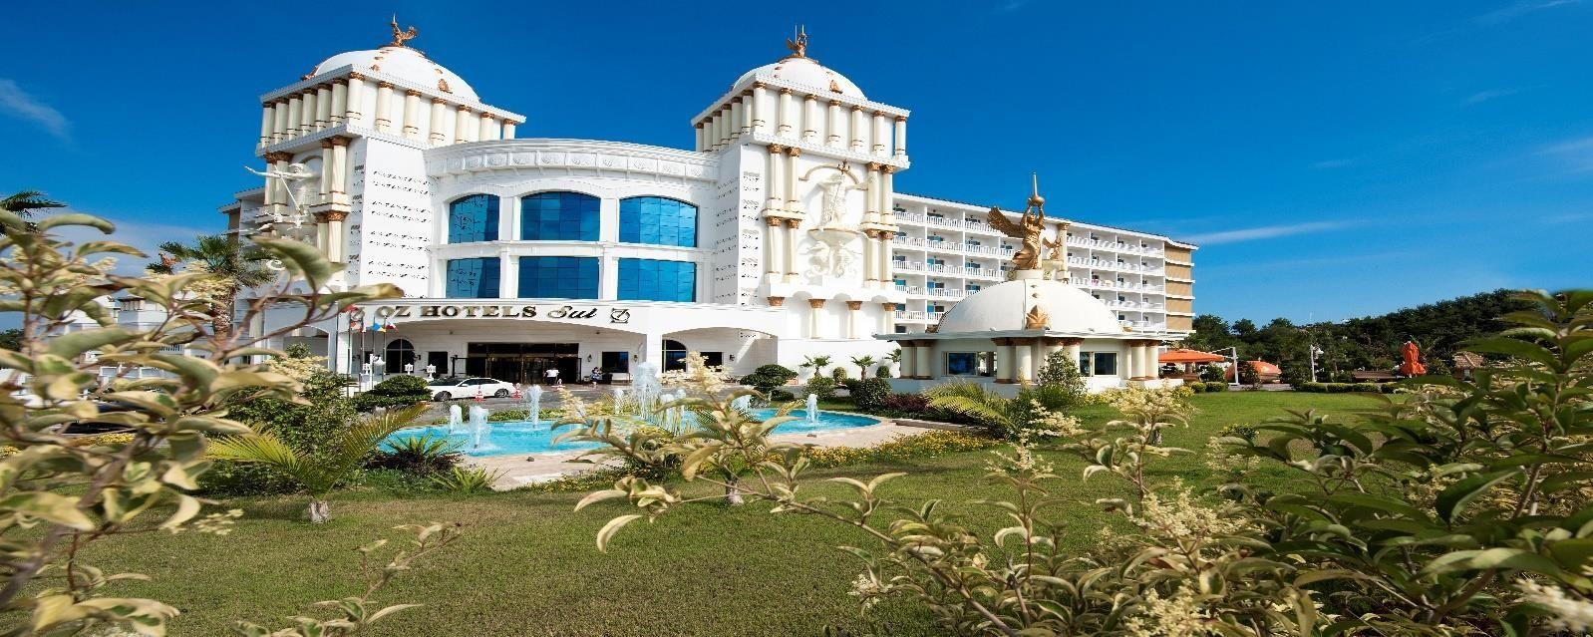

ROOMS:
275 Standard Rooms (25 m²) (4 rooms for disabled people)
It contains mini bar (the soft drinks are refreshed daily), satellite TV, music broadcasting, free internet connection, direct telephone line, free safe, tiled floor, bathroom/ shower & WC, make-up mirror and hair dryer, kettle (tea, coffee set-up).

28 Family Rooms (45 m²) (2 bedrooms)
In addition to standard room features, it provides a comfortable vacation for families with children with its 2 bedrooms, 1 bathroom and 2 televisions.

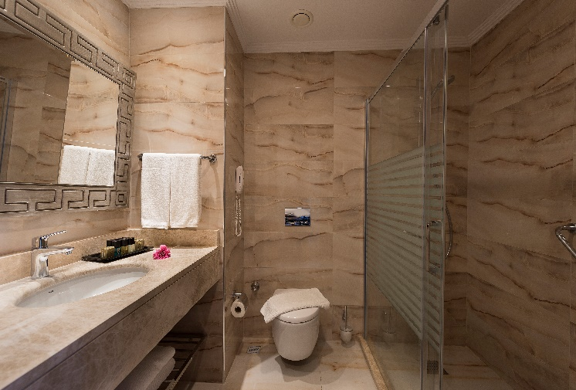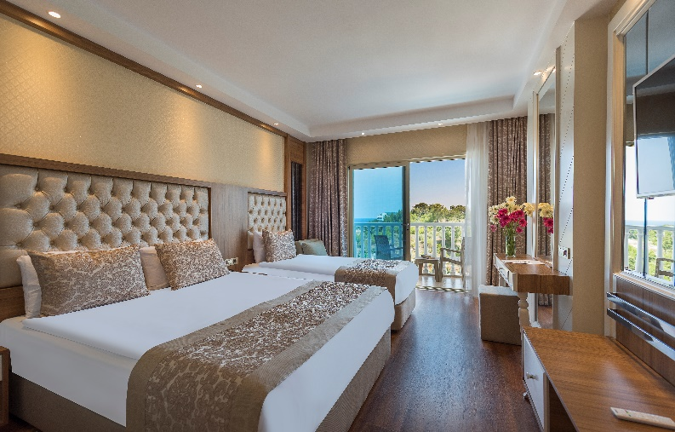

A’ LA CARTE RESTAURANTS (RESERVATION REQUIRED)

OTTOMAN A’LA CARTE 01.04/31.10
ITALIAN A’LA CARTE 15.05/31.10
FISH A’LA CARTE 15.05/31.10

** Opening and closing hours of the restaurants and the bards indicated above might vary based on operations of the facility and seasonal conditions.
** A'la carte restaurant use is valid for one restaurant for 1 time in minimum 7 days accomodations.
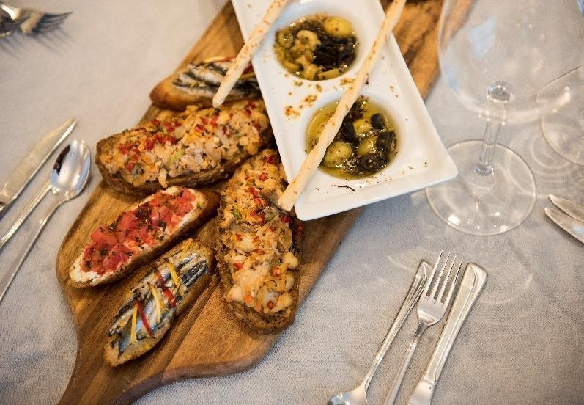
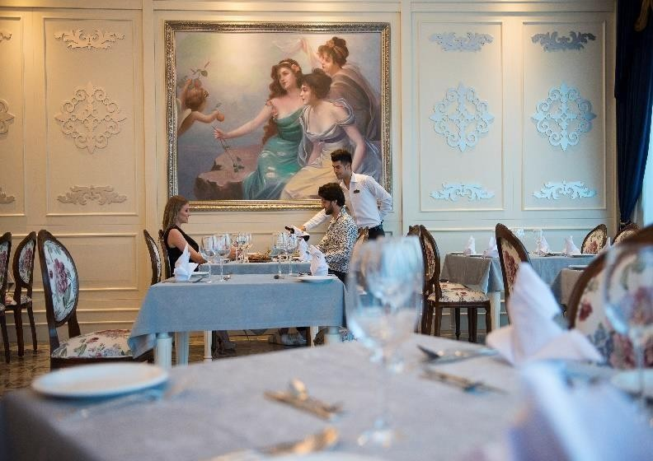

ALL INCLUSIVE: "All inclusive" system is implemented in our Sui Resort hotel. Alcohol and nonalcoholic beverages are free at all bars.
Import beverages certain are free at the lobby bar.

The beverages out of the concept are paid.

INTERNET: Wifi connection is provided free of charge in the rooms, general areas and at the beach.

SPA & WELLNESS:

In Sui Resort Spa center where all European massages and treatments are presented in addition to the far east therapies, there are personal treatment programs prepared in line with the guests' wishes. Sui Resort presents a perfect service to the guests in SPA Center consisting Turkish bath, sauna, steam room, resting rooms, classic massage rooms, special massage sections. Our VIP Spa taking place within our Spa unit, provides an extra service for our guests who want to feel themselves special and alone.

SPORTS: All types of land, water and extreme sports and opportunity to rest their body and spirit are provided to the guest in the water sports center located at the beach. There are treadmill, vertical stationary bicycle, horizontal stationary bicycle, rowing, step, multi-purposed gymnastic equipment, weight lifting platform available in the Fitness Center taking place in the Spa center. Besides, our guest can participate to various daily activities such as morning gymnastics, beach volleyball, dart, water gymnastics, water polo, pool games, step taking place amongst our daily activities and they can make their days delighted.

ACTIVITIES AND SUMMER SEASON SPECIAL ORGANIZATIONS:

The Pool, Indoor Pool, Ping Pong, Dart, Aerobic, Water Polo, Fitness programs, Movie, Concept parties and Disco are used free of charge.

While it is ensured that our guests spend their times in aqua park in daytimes and rich daytime animation activities and all types of sportive activities, they can enjoy live music, concept parties, dance shows and rich show programs prepared by an international animation team offered in the evenings. Our guests having accomodation in Sui Resort in summer period, will enjoy special organizations and taste memorable excitements.

OUR PAID SERVICES
All types of water activities taking place amongst waters sports that are operated privately at the beach and not belong to the hotel (Parasailing, Jet ski, Water ski, Ringo, Banana, Surfing and sailing), and massage, doctor services, room services, out of concept import beverages, telephone, facsimile, laundry services are paid services.

HONEYMOON CONCEPT:
Room ornament, special set-up, 1 breakfast to the room, 30 minutes free of charge massage, 1 free of charge A'la Carte are provided.

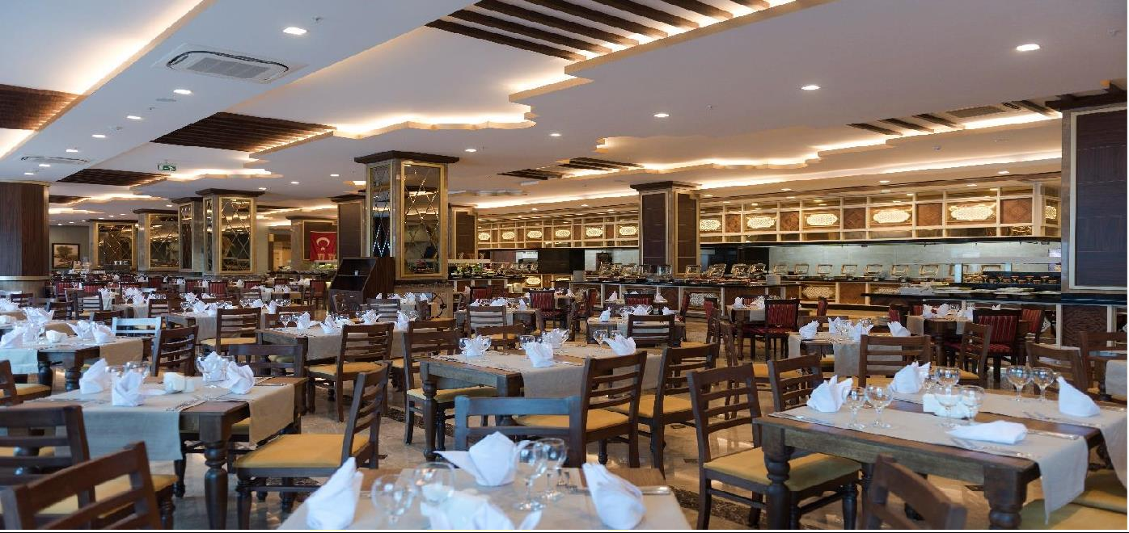

FOOD and BEVERAGES

Breakfast 07:30-10:00
Late Breakfast 10:00-10:30
Lunch 12:30-14:00
Dinner 19:00-21:00
Night Buffet 22:30-01:00
Night Buffet 01:00-06:00 (A’LA CARTE SERVICE)

Room Service (paid) 24 HOURS

BARS

Pool Bar 10:00-24:00
Lobby Bar 10:00-02:00
Beach Bar 10:00-17:30
Magic Disco 23:30-02:00
Chez Lavinia 09:00-18:00
Amphi Bar 20:00-23:30

SNACKS AND APPETISERS (SELF-SERVICE)

Pool Snack Restaurant 12:00-15:30
Pool Snack Appetisers 16:00-18:00
Turkish Pancake 11:00-15:30
Patisserie 15:30-18:00
Patisserie ice cream 15:30-18:00
Beach Snack Restaurant 12:00-15:30
Beach Ice Cream 15:30-17:00

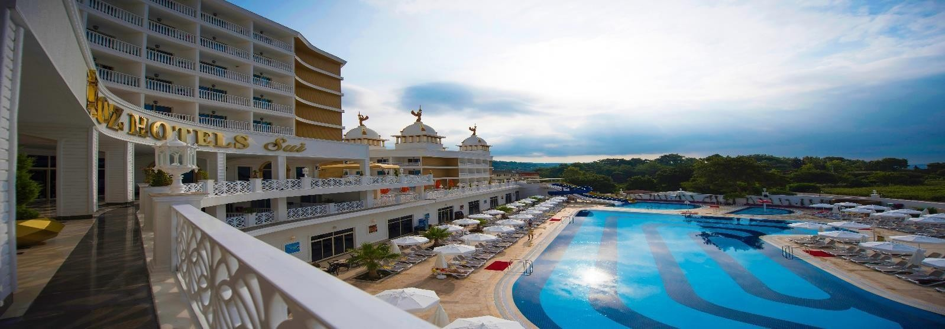

MINI CLUB:

SUI RESORT where little guests are not forgotten, there is a special service for children in the mini club for age group of 04-12. A restaurant for children, kiddy pool, special playgrounds, children shows organized based on age groups in company with trained and experienced professionals, Disco specially for children, movie service for children are provided. It offers a fairytale place where children can enjoy pleasure, energy and excitement experiences such as entertainment, different hobbies, discovering innovations, sports and recreation during the activities.

In entertaining our children's club, together with animators, also followings are provided where also educational plays and special activities prepared for 2 weeks:-
Educational programmes for all ages (4-12,) - Kids Restaurant
Special playground suitable for our little guests - T-shirt colouring (paid), colourful colouring activities by drawing their favourite characters - Face painting activities where they will find themselves in a fairytale world - A wide range of handicraft activities to put what they have learnt into practice - Colourful and enjoyable Pool Games, Kiddy Pool - Private outdoor Playground - Mini Disco -Brain Games Show, which teaches and entertains while teaching dancing, accompanied by trainers where they will spend a fun-filled time throughout the day

MNI CLUB HOURS 10:00-12:00/14:30-17:00
MINI DISCO HOUR .. 20:30-21:00

AQUAPARK and POOLS:
The Aquapark consisting 3 slides, provides service in between 10:30–12:00 and 14:30–16:30. Sui Resort presents a comfortable and joyful vacation opportunity to its guests even in its maximum intensity with its 2 pools consisting 830 m2 in total. Our outdoor pools were designed specially for entertainment activities consisting different alternatives such as water slides and pool games. 1 outdoor pool of ours was presented for use of our guests and all of them have 140 cm depth which is international standard. The kiddy pool is separate and it is 40 m2 and has 35 cm depth.
There is one indoor swimming pool and it is located in the spa center. The pools and our beach provide service based on weather conditions.

Aquapark Pool 140 cm Depth 105 m2
Main Pool 140 cm Depth 725 m2
Indoor Pool 140 cm Depth 100 m2

KIDDY POOLS
The kiddy pools were organize specially for enjoying swimming and sliding on the slides. Safe and warm environment of the kiddy pools make it a popular place booth for parents and children.
Outdoor kiddy pool 35 cm Depth Indoor kiddy pool 35 cm Depth

CONFERENCE HALL:
Sui meeting hall that was established on 160 m2 area, provides service with its total 150 persons capacity. Your all types of meetings, conferences, workshops and management seminars will be turned into memorable activities with our infrastructure and technical equipment that we will organize according to your special needs. Suit meeting hall attracting attention with 1 meeting room, 1 Tv room and 1 lounge, provides everything with its different design to its customers needed by business world.

Hall Name | Size (m) | Area (m2) | Height | Theatre Arrangement | Classroom Arrangement | U Arrangement | Banquet Arrangement
SELGE | 160 m2 | 160 m2 | 2,8 | 140 | 150 | 70 | 150
EFES | 150 m2 | 150 m2 | 2,8 | 120 | 100 | 60 | 100
PERGE | 55 m2 | 55 m2 | 2,8 | 50 | 40 | 32 | 48

*OZ HOTELS SUI, reserves right to make change in its concept without informing any third person or organization.

